Distress Types and Repair Methods

Rutting:
- Asphalt rutting Mill + FORTA-FI overlay
- Base/subgrade rutting Full depth repair needed

Description
Surface depression in the wheelpath. Pavement uplift (shearing) may occur along the sides of the rut. Ruts are particularly evident after a rain when they are filled with water. There are two basic types of rutting: mix rutting and subgrade rutting. Mix rutting occurs when the subgrade does not rut yet the pavement surface exhibits wheelpath depressions as a result of compaction/mix design problems. Subgrade rutting occurs when the subgrade exhibits wheelpath depressions due to loading. In this case, the pavement settles into the subgrade ruts causing surface depressions in the wheelpath.
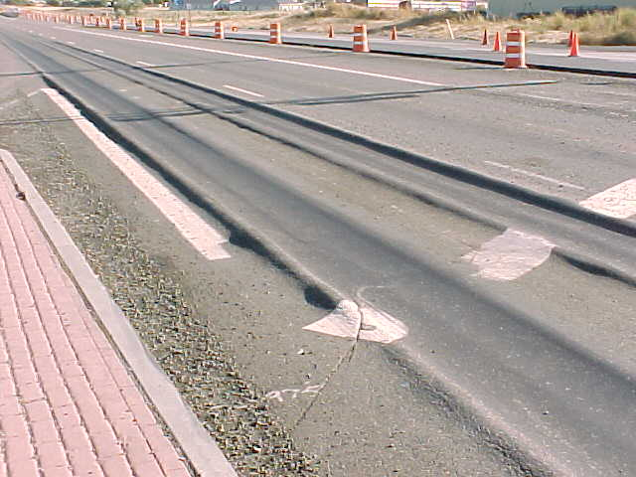  Figure 1: Severe mix rutting. | 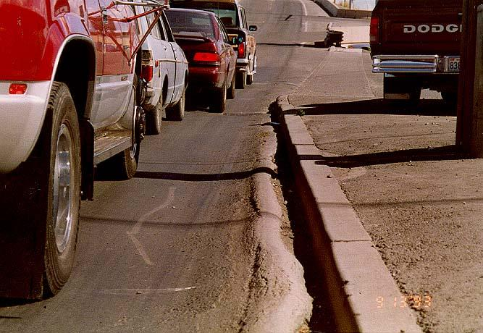  Figure 2: Mix rutting. | 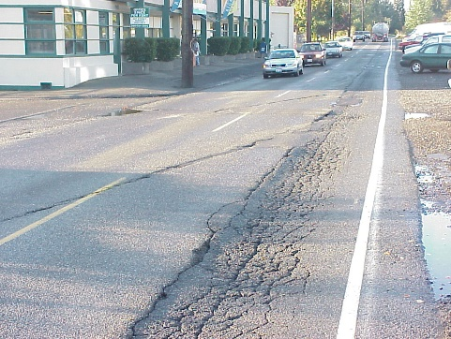  Figure 3: Outside wheelpath rutting

Problem
Ruts filled with water can cause vehicle hydroplaning, can be hazardous because ruts tend to pull a vehicle towards the rut path as it is steered across the rut.

Possible Causes
Permanent deformation in any of a pavement’s layers or subgrade usually caused by consolidation or lateral movement of the materials due to traffic loading. Specific causes of rutting can be:
- Insufficient compaction of HMA layers during construction. If it is not compacted enough initially, HMA pavement may continue to densify under traffic loads.
- Subgrade rutting (e.g., as a result of inadequate pavement structure)
- Improper mix design or manufacture (e.g., excessively high asphalt content, excessive mineral filler, insufficient amount of angular aggregate particles)
Ruts caused by studded tire wear present the same problem as the ruts described here, but they are actually a result of mechanical dislodging due to wear and not pavement deformation.

Repair
A heavily rutted pavement should be investigated to determine the root cause of failure (e.g. insufficient compaction, subgrade rutting, poor mix design or studded tire wear). Slight ruts (< 1/3 inch deep) can generally be left untreated. Pavement with deeper ruts should be leveled and overlayed.

Block cracking:
- If cracks are tight, cause is most likely pavement age/aging binder FORTA-FI overlay only
- Wider cracks + climate w/ temp swings i.e. possible thermal movement FORTA-FI overlay with RG

Description
Interconnected cracks that divide the pavement up into rectangular pieces. Blocks range in size from approximately 0.1 m² (1 ft²) to 9 m² (100 ft²). Larger blocks are generally classified as longitudinal and transverse cracking. Block cracking normally occurs over a large portion of pavement area but sometimes will occur only in non-traffic areas.
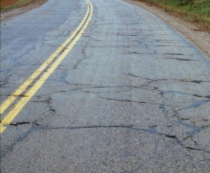  Figure 1: Block cracking on a low volume pavement | 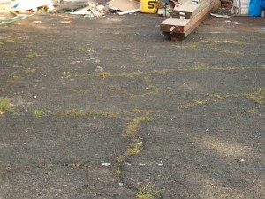  Figure 2: Block cracking in a residential driveway | 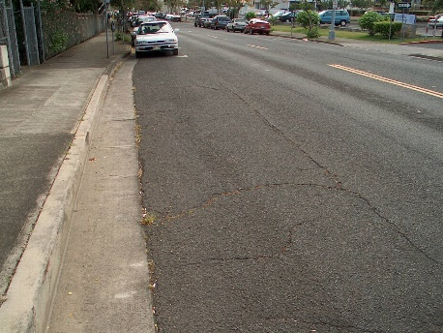  Figure 3: Block cracking in a curbside parking area.

Problem
Allows moisture infiltration, roughness

Possible Causes
HMA shrinkage and daily temperature cycling. Typically caused by an inability of asphalt binder to expand and contract with temperature cycles because of:
- Asphalt binder aging
- Poor choice of asphalt binder in the mix design

Repair
Strategies depend upon the severity and extent of the block cracking:
- Low severity cracks (< 1/2 inch wide). Crack seal to prevent (1) entry of moisture into the subgrade through the cracks and (2) further raveling of the crack edges. HMA can provide years of satisfactory service after developing small cracks if they are kept sealed (Roberts et. al., 1996^{[1]}).
- High severity cracks (> 1/2 inch wide and cracks with raveled edges). Remove and replace the cracked pavement layer with an overlay.

Fatigue cracking:
- With rutting, means base failure Digout and full depth repair
- Without rutting, means overloading of pavement FORTA-FI overlay

Description
Series of interconnected cracks caused by fatigue failure of the HMA surface (or stabilized base) under repeated traffic loading. In thin pavements, cracking initiates at the bottom of the HMA layer where the tensile stress is the highest then propagates to the surface as one or more longitudinal cracks. This is commonly referred to as “bottom-up” or “classical” fatigue cracking. In thick pavements, the cracks most likely initiate from the top in areas of high localized tensile stresses resulting from tire-pavement interaction and asphalt binder aging (top-down cracking). After repeated loading, the longitudinal cracks connect forming many-sided sharp-angled pieces that develop into a pattern resembling the back of an alligator or crocodile.
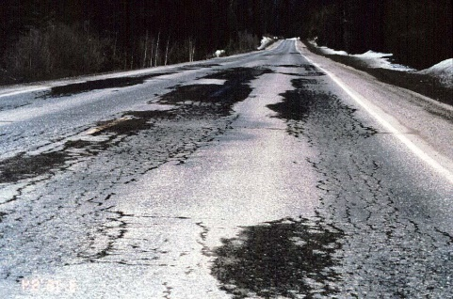  Figure 1: Fatigue cracking as a result of frost action | 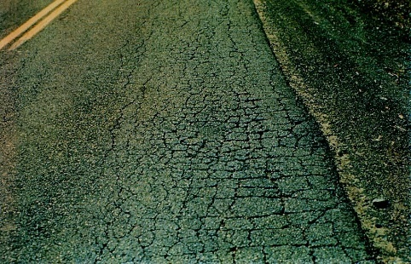  Figure 2: Very severely fatigued cracked pavement | 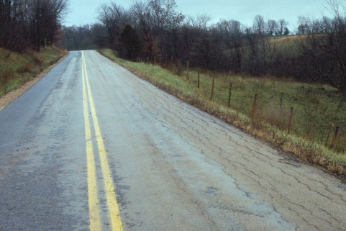  Figure 3: Fatigue cracking from a lack of edge support

Problem
Indicator of structural failure, cracks allow moisture infiltration, roughness, may further deteriorate to a pothole.

Possible Causes
Inadequate structural support, which can be caused by a myriad of things. A few of the more common ones are listed here:
- Decrease in pavement load supporting characteristics
  - Loss of base, subbase or subgrade support (e.g., poor drainage or spring thaw resulting in a less stiff base).
  - Stripping on the bottom of the HMA layer (the stripped portion contributes little to pavement strength so the effective HMA thickness decreases)
- Increase in loading (e.g., more or heavier loads than anticipated in design)
- Inadequate structural design
- Poor construction (e.g., inadequate compaction)

Repair
A fatigue cracked pavement should be investigated to determine the root cause of failure. Any investigation should involve digging a pit or coring the pavement to determine the pavement’s structural makeup as well as determining whether or not subsurface moisture is a contributing factor. Once the characteristic alligator pattern is apparent, repair by crack sealing is generally ineffective. Fatigue crack repair generally falls into one of two categories:
- Small, localized fatigue cracking indicative of a loss of subgrade support. Remove the cracked pavement area then dig out and replace the area of poor subgrade and improve the drainage of that area if necessary. Patch over the repaired subgrade.
- Large fatigue cracked areas indicative of general structural failure. Place an HMA overlay over the entire pavement surface. This overlay must be strong enough structurally to carry the anticipated loading because the underlying fatigue cracked pavement most likely contributes little or no strength (Roberts et. al., 1996^{[1]}).

Transverse cracking:
- Caused by thermal stresses Use RG to span crack

Description
Cracks perpendicular to the pavement’s centerline or laydown direction. Usually a type of thermal cracking.
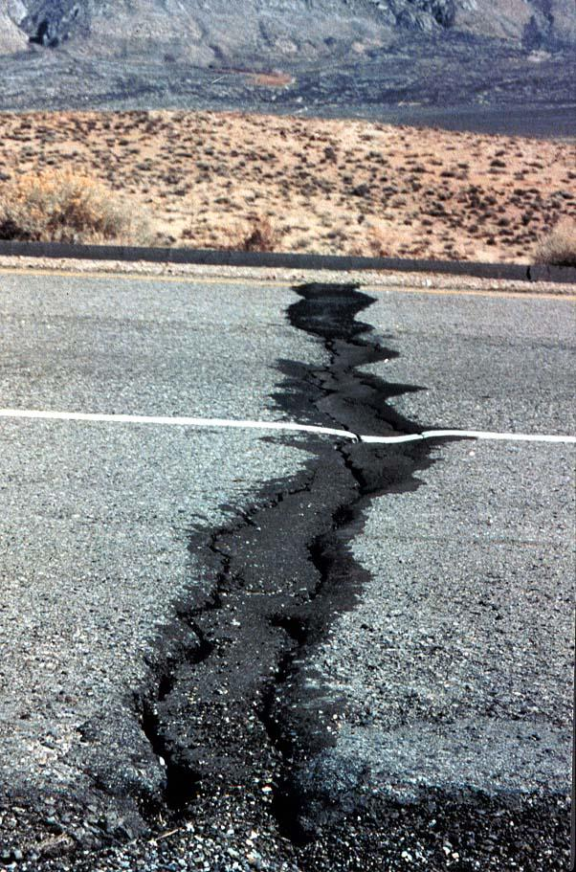  Figure 1: Large transverse crack. | 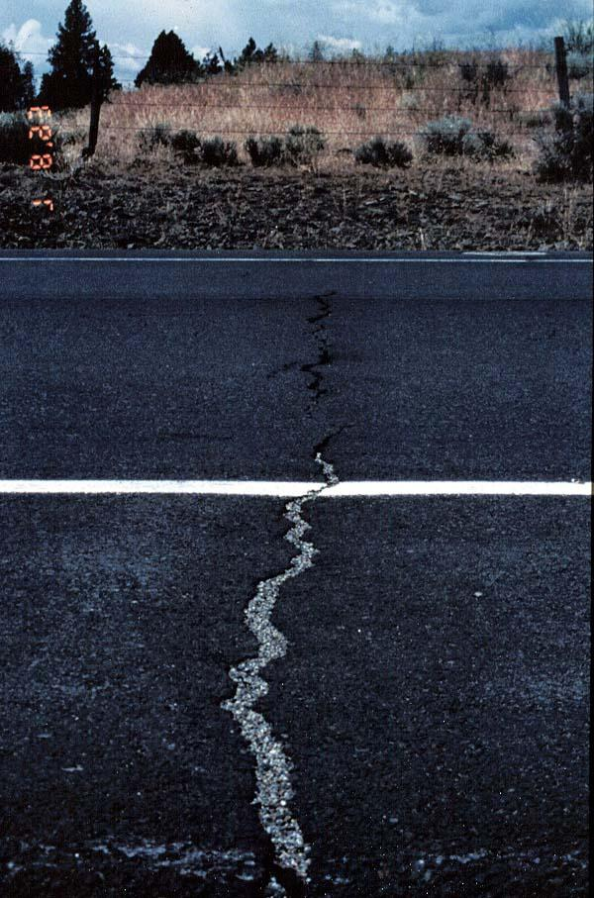  Figure 2: Transverse crack. | 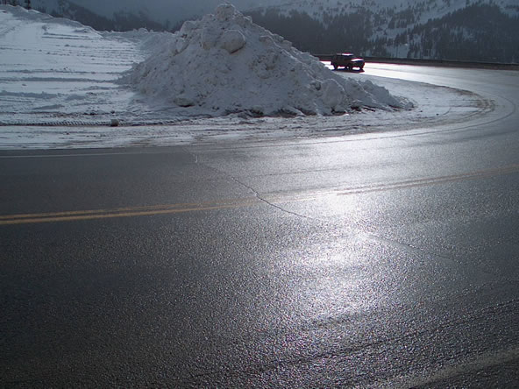  Figure 3: Small transverse crack.

Problem
Allows moisture infiltration, roughness

Possible Causes
Several including:
- Shrinkage of the HMA surface due to low temperatures or asphalt binder hardening
- Reflective crack caused by cracks beneath the surface HMA layer
- top-down cracking

Repair
Strategies depend upon the severity and extent of the cracking:
- Low severity cracks (< 1/2 inch wide and infrequent cracks). Crack seal to prevent (1) entry of moisture into the subgrade through the cracks and (2) further raveling of the crack edges. HMA can provide years of satisfactory service after developing small cracks if they are kept sealed (Roberts et. al., 1996^{[1]}).
- High severity cracks (> 1/2 inch wide and numerous cracks). Remove and replace the cracked pavement layer with an overlay.

Overlays over concrete:
- Always use RG + FORTA-FI for longest lasting repair

